Individual Assignment (PLDP)

Each student requires to write a personal leadership development plan (PLDP). The plan report should not be less than 2500 words and not more than 3000 words excluding the cover page, table of contents and reference list. The marking rubric is enclosed to the last section of this document. The assignment weight is 30% and the written PLDP report is due in week 6.

The assignment needs to be typed, in the following format:

Font size 12 point, spacing 1.5, top and left margins set at 2.5 (normal). The pages need to be numerated. In the content list page, numbers are to be given under the different sub-headlines. New paragraphs are to be marked by skipping a line, it is not to be marked by indentation. Headlines are to be written from the left margin, not centred.

The plan writing guidelines are provided as below:
What is a Leadership Development Plan?
In order to be highly effective in today’s unpredictable business climate, your leaders must be able to address both strategic and “human” needs within your company. A leadership development plan is designed to build key leadership qualities and competencies in your current and future leaders. It maps out specific approaches to developing leadership skills within set time frames, while never losing sight of your primary goals — to achieve key business results while retaining top talent.
6 Steps for Creating & Measuring the Success of a Leadership Development Plan
To achieve desired outcomes, your leadership development plan must be relevant for leaders in each level of your company, with the ability to meet their needs as their careers progress. This ensures they are always performing optimally. The key steps for creating a leadership development plan and measuring its success as follows:
- Home in on key business objectives. Outline the primary business goals you are focused on achieving in a simple, easily understood manner. One example could be achieving 30% improvement in closed sales in 12 months.
- Define core leadership qualities. To do so, you can write a list of the leadership traits, competencies, and abilities you feel a strong leader embodies. When complete, you can get feedback from senior leadership regarding the list in order to identify the skills that matter most to your company.
- Conduct a leadership skills assessment. Identify the specific leadership skills that need to be developed at your company in order to achieve key business objectives via a leadership skills assessment. There are many ways to perform a leadership skills assessment including speaking with leaders to find out what they feel they need to be more successful, as well as gathering insights from teams regarding their leaders. Feedback can be obtained via a variety of methods including email feedback, anonymous feedback, and face-to-face feedback.
- Develop a list of leadership development plan objectives. Using what you learned from the leadership skills assessment and your knowledge of the skills that matter most to your company, outline a list of realistic desired outcomes for your leadership development plan. Tie the outcomes to achieving business goals whenever possible.
- Identify the best methods to achieve leadership development plan objectives. Considerations when it comes to achieving leadership development plan objectives include selecting relevant content as well as the best training formats – in-person classroom, virtual classroom, self-paced asynchronous learning, one-on-one coaching, or group coaching. Many companies find it is far more efficient to bring in a third-party that specializes in leadership development since they can quickly identify relevant content and best-fit training formats as well as deliver the training.
- Measure the effectiveness of your leadership development plan: It’s important to establish concrete criteria for measuring the success of your leadership development plan. Feedback from employees regarding their progress as well as analysis of how your leaders’ departments are performing should be included. Over time, taking a look at how long leaders stay with your company and how they excel in their careers is another way to measure success.
To help ensure enthusiastic company-wide acceptance of your leadership development plan, it’s a good idea to create a culture of leadership at your company. This lets every employee know they are supported to grow as a leader and will result in their feeling more enthusiastic about their work and your company.

Sample (Leadership Development Plan)

1. Introduction
The purpose of this personal development plan (PDP) is to provide the reader with a critical analysis and transparent appraisal of my leadership skills and competencies as well as strengths and weaknesses. In addition, this personal analysis allows for considering my future leadership development. The PDP consists of an introduction, personal analysis, objectives for personal development, action plan and conclusion.
2. Personal Analysis
I am a 25-year-old graduate working for a medium-sized organisation that operates in the service industry. I joined this company while at university and transferred to my current department right after graduation. I was encouraged by the firm’s management to enter a leadership development programme. The programme is scheduled to begin in September 2018 and will take two months. This is a good opportunity for me to further develop my leadership skills and competencies. However, I firstly have to conduct a personal analysis in order to identify my strengths and weaknesses as well as the potential areas of further development. This analysis is conducted with the help of the SWOT framework, which uncovers my strengths and weaknesses, opportunities and threats (Dugan, 2017).
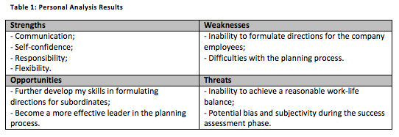
According to the trait theory of leadership, effective leaders should possess a wide range of physiological, demographic, intellective and task-related characteristics (Owen, 2015). As noted by Rickards (2015), successful leaders have interests, personality traits and abilities, which are different from those of the less effective leaders. In my opinion, I possess certain skills and qualities, which can allow me to become a good leader in the future. For example, my communication skills are well-developed. I can effectively communicate with both individuals and groups and express myself in a clear manner without engendering murkiness or confusion. At the same time, I must say that the lack of experience as a leader may limit my ability to effectively and clearly formulate directions for the company’s employees. Self-confidence was also argued by Lussier and Achua (2015) as one of the most important traits of a successful leader. I can take risky decisions and accomplish complex tasks. Nevertheless, I totally accept responsibility for these decisions and their potential failure to achieve the initial goals.
My analytical and conceptuality skills are also well-developed as I am able to visualise, articulate and solve complex problems and work effectively under pressure. I totally understand that the business world of today is fast-changing (Nevarez et al., 2015). That is why, I am trying to be as flexible in the workplace as possible. As a leader, I accept whatever changes come their way and take my leadership decisions in the light of these changes. According to Northouse (2015), the planning process in the context of leadership implies setting a vision for a company as well as realising this vision through achievable objectives. I must admit, however, that I am experiencing certain difficulties with the strategic planning process. My understanding of the planning process is still too limited to allow me to become an effective leader. My experience in leading and managing others is not considerable, which, in my opinion, is the main reason for the previously noted weakness. The extent to which my leadership skills and competencies are developed can be presented by means of the following chart, where 10 is ‘highly developed’ and 0 is ‘not developed at all’.
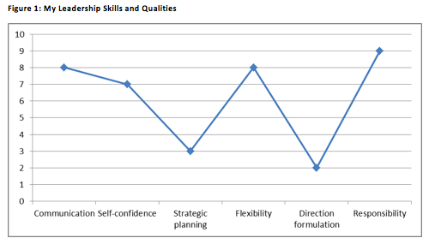
Based on the personal assessment above, I can say that the development of my skills and qualities in formulating directions for subordinates and in the planning process are the main opportunities provided by the leadership development programme. At the same time, it may be difficult to maintain a reasonable work-life balance during my academic studies. In accordance with Braun and Nieberle (2017), leaders’ inability to maintain this balance can result in negative attitudes (e.g. anxiety and anger) and ultimately lead to burnout.

3. Objectives for Personal Development
The objectives for my personal development are formulated with the help of the SMART criteria, which imply that objectives must be specific, measurable, achievable, relevant and time bound (Nevarez et al., 2015). These objectives are presented as follows.
- To further develop my skills and qualities in formulating the directions for subordinates by the end of November 2018.
- To contribute to my ability to set a vision for my company/department and realise this vision through achievable objectives by the end of December 2018.
- To widen my understanding of leadership by the end of December 2018.

4. Action Plan
The action plan, which contains the development goals, actions, success measures and schedule goals, is presented by means of the following table.
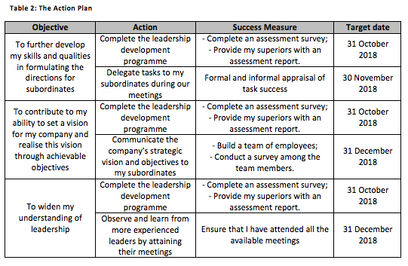
Each objective requires two actions to be performed. The first action is to complete the leadership development programme by the end of October 2018 and provide my superiors with an assessment report. In turn, the second action requires the practical application of my newly developed leadership skills and competencies within the next two months.
I am planning to achieve the first personal development objective by completing the leadership development programme. I believe that this programme will contribute to my leadership knowledge and will help me formulate clearer directions for the company’s employees and, hence, add to their productivity and performance in the workplace (Lussier and Achua, 2015). I am planning to measure the effectiveness of this action by completing an assessment survey and providing its results to my superiors. It should be noted, however, that this assessment method can result in the production of biased and subjective data as its results would be based exclusively on my own perceptions (Rickards, 2015). The practical side of the first objective will include delegating tasks to my subordinates during our post-programme meetings. During this phase, I will be able to apply my newly acquired leadership skills and competencies in a practical context. The effectiveness of my ability to formulate directions for subordinates will be assessed on the basis of formal and informal appraisals of task success (Dugan, 2017).
The next personal development objective will also require performing two actions. Similar to the previously discussed objective, the first phase of the second objective will require the completion of the leadership development programme. In turn, after the assessment of my newly developed leadership skills, I am planning to communicate my organisation’s strategic vision and objectives to my subordinates to identify whether I can use these skills in practice. For this purpose, I am planning to create a team of employees and communicate the firm’s vision and goals to its members. As noted by Lindsjorn et al. (2016), individuals demonstrate higher levels of commitment and engagement working in teams. Thus, by building this team, I will be able to assess my strategic planning skills in a more effective manner. To measure the success of this action, I am going to conduct a survey among the team members. Although this approach to success assessment is preferable, the team members can provide the answers they think they are expected to provide (Saunders et al., 2015). This fact can be viewed as a threat to the credibility of the obtained responses.
Finally, the third personal development objective, which is to widen my understanding of leadership, is going to be achieved through the completion of the leadership programme. Nevertheless, I am planning to broaden my leadership knowledge by observing and learning from more experienced leaders. For this purpose, I will attend all the meetings of these leaders that will be held during a two-month period (November-December 2018). In accordance with Nylund and Raelin (2015), knowledge sharing allows for ensuring that knowledge is articulated and accessed by all organisational members. At the same time, Tee (2015) noted that only explicit knowledge can be shared. Hence, by attending these meetings, I will not be able to capture tacit leadership knowledge, which can be viewed as a limitation of the selected success assessment method.
5. Conclusion
The participation in the leadership development programme is expected to help me further develop my leadership skills and qualities in formulating directions for subordinates; contribute to my ability to set a vision for my company and realise this vision through achievable objectives; and widen my understanding of leadership. At the same time, practical actions are also needed to ensure the effectiveness of this programme. For this purpose, I am planning to arrange frequent meetings with my subordinates, actively delegate tasks during these meetings, facilitate teamwork and learn from more experienced leaders. Completing the leadership programme (September-October 2018) is not a finite goal, but rather a start in developing my understanding of practical leadership.

References
Braun, S. and Nieberle, K. (2017) “Authentic leadership extends beyond work: A multilevel model of work-family conflict and enrichment”, The Leadership Quarterly, 28 (1), pp. 780-797.
Dugan, J. (2017) Leadership Theory: Cultivating Critical Perspectives, Chichester: John Wiley & Sons.
Lindsjorn, Y., Sjoberg, D., Dingsoyr, T., Bergersen, G. and Dyba, T. (2016) “Teamwork quality and project success in software development: A survey of agile development teams”, Journal of Systems and Software, 122 (1), pp. 274-286.
Lussier, R. and Achua, C. (2015) Leadership: Theory, Application, & Skill Development, London: Cengage Learning.
Nevarez, C., Wood, L. and Penrose, R. (2015) Leadership Theory and the Community College: Applying Theory to Practice, Sterling: Stylus Publishing.
Northouse, P. (2015) Leadership: Theory and Practice, New York: SAGE.
Nylund, P. and Raelin, J. (2015) “When feelings obscure reason: The impact of leaders’ explicit and emotional knowledge transfer on shareholder reactions”, The Leadership Quarterly, 26 (4), pp. 532-542.
Owen, J. (2015) Innovative Learning for Leadership Development: New Directions for Student Leadership, Chichester: John Wiley & Sons.
Rickards, T. (2015) Dilemmas of Leadership, London: Routledge.
Saunders, M., Lewis, P. and Thornhill, A. (2015) Research methods for business students, 7th ed., London: Prentice Hall.
Tee, E. (2015) “The emotional link: Leadership and the role of implicit and explicit emotional contagion processes across multiple organizational levels”, The Leadership Quarterly, 26 (4), pp. 654-670.
Marking Rubric for Written Report
MARKING CRITERION | ASSESSMENT WEIGHT | MARK | COMMENTS
1. Presentation  -Fulfilled the required structure, cover sheet, words limit, etc. | 5
2. Introduction  -Background to report.  -Statement of purpose.  -Outline of the report. | 5
3. Body  -Paragraph structure (topic sentences etc.).  -Main points are debated.  -Cohesion (logic sequence, links between paragraphs). | 50
4. Conclusion  -Restate the report & relates to its purpose.  -Summarize main points.  -Consistency between the arguments provided in the body section and the statement of conclusion | 5
5. Academic English  -Grammar, spelling, syntax, punctuation, expression, tone, vocabulary, flow. | 10
6. Critical analysis and use of evidence -Critical approach.  -Appropriate & sufficient evidence.  -Integration of evidence & depth of analysis. | 10
7. Overall quality of the plan  -Represents an excellent report and provides a significant contribution.  -Engages with the business strategy elements & the degree of success in doing so. | 15
Total Mark | 100

